1. {{**typeScriptExpression**}}: Thy typescript expression can be one of the following but eventually, it must be evaluated to a string value.
   1. {{‘StringItSelf’}}
   2. {{ componentPropertyName}}
   3. {{componentMethodCall()}}

**NOTE**: What if the property is not a string and you’re using in string interpolation.

Then that property must be easily convertible into string at the end. Such as property 🡺 age:number = 10; then {{age}} find as number can be converted.

1. 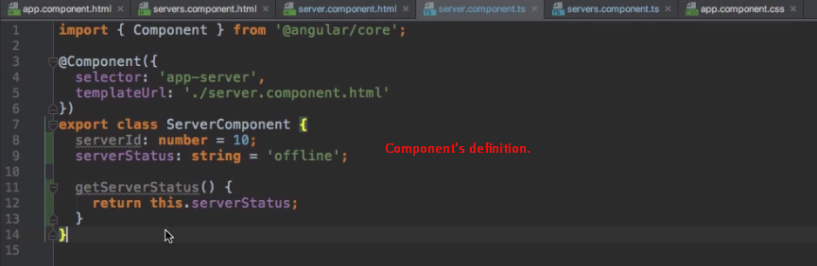
2. 